**Primary Keyword(s)**

Commercial Fans - 1,700

Industrial Fans - 7,100

**Secondary Keyword(s)**

big shop fans - 700

large industrial fans - 600

small industrial fan - 250

big industrial fans - 350

heavy-duty industrial fan - 400

industrial ceiling fans - 3,800

|  |  |
| --- | --- |
| **Title:** | Large Industrial Ceiling Fans | Quote Big & Small Commercial Fans - Hunter Fans |
| **Recommended Meta Description:** | Order industrial fans from Hunter Fans. Our industrial ceiling fans are built to withstand demanding environments and provide powerful airflow for effective cooling. Shop commercial fans from Hunter Fans. |
| **H1:** | Commercial & Industrial Ceiling Fans |
| **URL Path:** | /large-commercial-and-industrial-ceiling-fans/ |
| **Alt Tags:** | Reference The Design Task For Alt Tags For Images |
| **CTAs:** | Model: https://industrialfans.hunterfan.com/pages/agriculture |

**Page(s) To Boost/Anchor Text**

* <http://industrialfans.hunterfan.com/collections/industrial-hvls-fans>
* <http://industrialfans.hunterfan.com/pages/aviation>
* <http://industrialfans.hunterfan.com/pages/automotive>
* <http://industrialfans.hunterfan.com/pages/manufacturing>
* <https://industrialfans.hunterfan.com/pages/warehouse>
* <https://industrialfans.hunterfan.com/pages/fitness-recreation>

# **Top Copy**

# Commercial & Industrial Ceiling Fans

**Hunter Industrial is a leading provider of powerful and efficient High-Volume, Low Speed (HVLS) commercial and industrial ceiling fans explicitly designed for their respective applications.** Our HVLS industrial and commercial fans, engineered to meet the demanding needs of large-scale facilities, are renowned for their unrivaled performance, superior airflow, and reliable operation. Whether it's cooling expansive warehouses, maximizing ventilation in manufacturing plants, or optimizing air circulation in gymnasiums, we offer a wide range of robust and energy-efficient solutions, setting a new standard for comfort and productivity in commercial environments.

**Bottom Copy**

## Industrial Fans Enhance Comfort & Efficiency Wherever You Need It

It’s obvious that industrial fans are standard in certain commercial settings. But you may be surprised to discover that they also deliver exceptional airflow and cooling capabilities in many lesser-known venues:

* **Agricultural Facilities:** Designed to improve air circulation and reduce moisture levels in [agricultural settings](https://industrialfans.hunterfan.com/pages/agriculture), these commercial fans contribute to a healthier environment for livestock, preventing heat stress, improving productivity, and promoting optimal growth.
* **Warehouses:** Ideal for large-scale [warehouse facilities](https://industrialfans.hunterfan.com/pages/warehouse), our big shop fans effectively circulate air, reduce the effects of humidity, and maintain a comfortable working environment for employees.
* **Commercial Kitchens:** With their high-performance airflow, our industrial fans aid in proper ventilation and smoke extraction, improving air quality and comfort for the kitchen staff.
* **Manufacturing Plants:** Heavy-duty industrial fans enhance ventilation, improve air quality, and promote worker safety in [manufacturing plants](http://industrialfans.hunterfan.com/pages/manufacturing) by effectively dissipating heat and removing fumes and airborne particles.
* **Sports Arenas:** By efficiently distributing cool air throughout sports arenas, our commercial fans deliver a pleasant spectator experience and enable athletes to perform at their best.
* **Gymnasiums:** Commercial fans offer excellent air circulation, ensuring consistent temperature control and improved air quality during intense workouts and sports activities in [gyms and fitness centers](https://industrialfans.hunterfan.com/pages/fitness-recreation).
* **Factories:** Big industrial fans enhance overall airflow and promote effective temperature regulation, creating a conducive environment for increased productivity and employee well-being.
* **Distribution Centers:** HVLS industrial ceiling fans help maintain uniform temperatures, preventing hotspots and optimizing product preservation, thereby ensuring a favorable environment for goods storage and handling.
* **Auto Repair Shops:** Owners use big shop fans to provide powerful air movement, assisting in the removing [hazardous fumes](https://www.osha.gov/autobody#:~:text=Chemical%20hazards%20may%20include%20volatile,fumes%20from%20welding%20and%20cutting.), such as exhaust gases, solvents, and chemicals in [automotive shops](http://industrialfans.hunterfan.com/pages/automotive), creating a safer and healthier workspace.

## Commercial Fans for Large & Small Spaces

Whether you're trying to cool a huge warehouse or a small shop, you're going to need commercial fans that provide an efficient solution to your needs. **We've tailored our industrial fans to serve clients from businesses of all sizes.** From Titan, our powerful, heavy-duty industrial fan, to the Trak, the small commercial fan designed for open-concept spaces, there's a Hunter Industrial & Commercial fan for every workplace.

[Products]

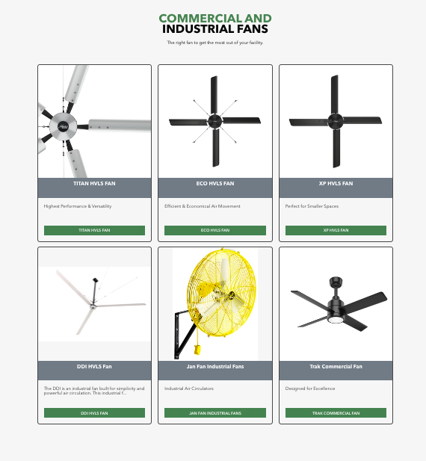

## Frequently Asked Questions About Commercial Fans

If you'd like to learn more about our commercial fans, please let us know. In the meantime, here are answers to some of the questions other customers have asked:

### What Is the Difference Between Industrial & Commercial Fans?

The truth is, the terms “Industrial Fan” and “Commercial Fan” are often used interchangeably. At Hunter Industrial & Commercial, we use the term “Industrial Fan” when referring to our lineup of HVLS (High-Volume, Low-Speed) fans that measure between 7’-24’ in diameter. When we use the term “Commercial Fan,” we are referring to fans like our Trak fan, which is more like the kind of fan you would have in your home, only upgraded to meet the needs of commercial applications. We’ve developed both large and small fans to control the airflow in all the businesses we serve!

### What Is an Industrial-Grade Fan?

An industrial-grade fan is specifically designed and built to meet the demands of industrial applications. It's characterized by its robust construction, high performance, durability, and ability to withstand harsh environments.

### What Is a Commercial-Grade Fan?

A commercial-grade fan is engineered for commercial applications. It's tailored for use in commercial spaces such as offices, retail stores, restaurants, hotels, and other similar environments.

### What Are Industrial Fans Used For?

Industrial fans are used in a wide range of applications across various industries due to their ability to generate powerful airflow and provide effective ventilation. Common uses include cooling, ventilation and [industrial dust](https://www.ncbi.nlm.nih.gov/pmc/articles/PMC6617327/#:~:text=From%20a%20health%20point%20of,dust%20and%20they%20sediment%20rapidly.)/particle control.

## Our Fans Speak

“The air movement is so powerful, and everyone who comes in the shop asks about them. They’re absolutely awesome fans and keep us cool every day.” – Justin Annarino, owner of Key’s Custom Automotive

## At Hunter, We Care About Our Customers, and it Shows

We've worked hard to make the best commercial and industrial fans around, and we're not about to risk our reputation. We back our Titan, ECO, and XP industrial fans with a [Limited Lifetime Warranty](https://cdn.shopify.com/s/files/1/0555/5434/3079/files/Hunter_Industrial_Warranty_Statement_2022_2.pdf?v=1662491932) – the best warranty in the industry – because we believe in the quality of our industrial ceiling fans. Furthermore, we're here when you need us, from the time you press the "order" button to delivery to installation and cleaning. If you have a question about our products or services, just give us a call: 1-844-591-3267.

## Clear the Air With Commercial Fans From Hunter Industrial

**Hunter's industrial and commercial fans are the trusted solution for your ventilation needs.** Whether your goal is cooling a large warehouse, improving air circulation in a manufacturing facility, or enhancing comfort in a commercial space, our large industrial fans offer unmatched performance and durability. Contact us today to discover how Hunter Industrial Fans can meet your needs for a better work environment.

## VIDEO: HVLS Fan Blade Durability | Hunter Industrial

What happens when a basketball goes head-to-head with our HVLS heavy-duty industrial fan blades? Find out in this demonstration. Spoiler alert: We take on footballs, tennis balls, and soccer balls, too.

|  |
| --- |
| **VIDEO EMBED:** |
| **<iframe width="560" height="315" src="https://youtu.be/Ol0Wq2XwvfY" frameborder="0" allow="accelerometer; autoplay; encrypted-media; gyroscope; picture-in-picture" allowfullscreen></iframe>** |

**Content Wheel Copy**

## **Related Articles: Commercial Fans**

|  |  |  |
| --- | --- | --- |
| [**Solutions to Your Warehouse Cooling Problems**](https://industrialfans.hunterfan.com/blogs/hunter-industrial-blog/warehouse-cooling)  Delve into the cooling problems warehouses experience and discover solutions that can improve conditions within these large spaces. | [**Hunter Industrial Fans Spotlight: The Trak Commercial Fan**](https://industrialfans.hunterfan.com/blogs/hunter-industrial-blog/hunter-fans-spotlight-the-trak-commercial-fan)  Learn about the Trak small industrial fan, Hunter’s ideal combination of air circulation and aesthetic appeal. | [**The Most Innovative HVLS Fans on the Market**](https://industrialfans.hunterfan.com/blogs/hunter-industrial-blog/hvls-fan-innovation)  Discover the innovations that set Hunter Industrial apart from all the rest. |

**FAQ Schema:**

{

"@context": "https://schema.org",

"@type": "FAQPage",

"mainEntity": [

{

"@type": "Question",

"name": "What Is the Difference Between Industrial & Commercial Fans?",

"acceptedAnswer": {

"@type": "Answer",

"text": "There was a time when there was a big distinction between industrial and commercial fans. Industrial fans were big, noisy affairs, while commercial fans were smaller and quieter. We closed the gap between commercial and industrial fans by engineering HVLS fans that manage airflow effectively, are energy-efficient and quiet, to boot. We've developed both large and small industrial fans to manage the airflow in all the businesses we serve."

}

},

{

"@type": "Question",

"name": "What Is an Industrial-Grade Fan?",

"acceptedAnswer": {

"@type": "Answer",

"text": "An industrial-grade fan is specifically designed and built to meet the demands of industrial applications. It's characterized by its robust construction, high performance, durability and ability to withstand harsh environments."

}

},

{

"@type": "Question",

"name": "What Is a Commercial-Grade Fan?",

"acceptedAnswer": {

"@type": "Answer",

"text": "A commercial-grade fan is a type of fan designed and built to meet the requirements of commercial applications. It's specifically tailored for use in commercial spaces such as offices, retail stores, restaurants, hotels and other similar environments."

}

},

{

"@type": "Question",

"name": "What Are Industrial Fans Used For?",

"acceptedAnswer": {

"@type": "Answer",

"text": "Industrial fans are used in a wide range of applications across various industries due to their ability to generate powerful airflow and provide effective ventilation. Common uses include cooling, ventilation and dust/particle control."

}

}

]

}